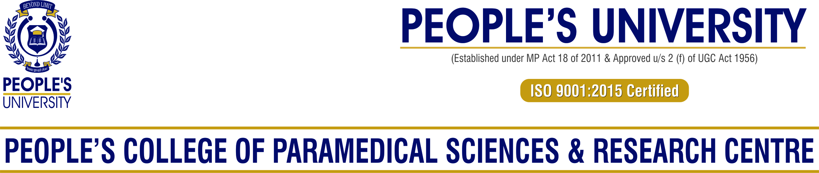

**Minutes of relevant BoS meetings**

BOS/11/01: Syllabus of BPT Program.

**The Board approved the revision in syllabi of the Human Anatomy, (05A) . Revised scheme is being offered from Academic Session 2017-18.**

**Details of the revised Curricula/Syllabi (Sample)**

Name of Program: BPT

Name of Course & Code: Human Anatomy (BPT-101)

Revised Syllabi: 18th July 2016

**Syllabus prior and post revision of the courses. (Point Wise) (Sample)**

Name of Program: BPT

Name of Course & Code: Human Anatomy (BPT-101)

|  |  |
| --- | --- |
| Prior Revision | Post Revision |
|  | Regional Anatomy:   1. Superior Extremity:   Osteology: Clavicle, Scapula, Humerus, Radius, Ulna Carpals, Metacarpals.  Soft Parts: Breast, Pectoral region, Front of arm, Back of arm, Cubital fossa, front of forearm, nerves & vessels of forearm, paim, Dorrsum of hand,shoulder gridle, joints of hand.   1. Inferior Extremity:   Osteology: Hip bone, femur, tibia, fibula & Patella, tarsals, metatarsals.  Soft Parts: Front of thigh- femoral canal & femoral hernia, Adductor canal, medical compartment of thigh, glutel region, back of thigh, popliteal fossa, Anterior compartment of leg, posterior compartment of leg, sol of foot, venous drainage of leg, hip joint, ankle joint, tarsal joints.  Trunk:  Osteology: Cervical, thoracic & lumbar vertebra, sacrum, coccyx & Ribs.  Soft tissue: Inter-vertebral joints, costo-vertebral joints, Inter-vertebral Disc, ligaments & muscle.  Skull as a whole & mandible.  Demonstration of dissected parts.  Parts of limbs, trunk, brain, thorax & abdominal contents. |

**Minutes of relevant BoS meetings**

BOS/19/02: Syllabus of DDT & DMLT Program.

**The Board approved the revision in syllabi of the Fundamental of Dialysis (DDT-01C) & Biochemistry & Clinical Pathology (DMLT-02C) . Revised scheme is being offered from Academic Session 2020-2021.**

**Details of the revised Curricula/Syllabi (Sample)**

Name of Program: DDT & DMLT

Name of Course & Code: Fundamental of Dialysis(DDT-102) & Biochemistry & Clinical Pathology (DMLT-102)

Revised Syllabi: 23rd June 2020

**Syllabus prior and post revision of the courses. (Point Wise) (Sample)**

Name of Program: DDT & DMLT

Name of Course & Code: Fundamental of Dialysis (DDT-102), & Biochemistry & Clinical Pathology (DMLT-102)

|  |  |
| --- | --- |
| Prior Revision | Post Revision **(DDT)** |
|  | *Approach to Patients with Chronic Kidney Diseases as per Stages* |
|  | *Brief overview of various Medical conditions :-*  *Definition, Type, Presentation and Consequences/Complications of Diabetes, Hypertension, Coma, Left Ventricular Failure, Hepatic Disorders and Bladder Dysfunction.* |
|  | **DMLT** |
|  | ***Amino Acids - Definition, Classification*** |
|  | ***Nucleic acid- DNA, RNA structure and function*** |
|  | ***Factor affecting enzyme activity*** |
|  | ***Enzyme inhibiton*** |
|  | ***Clinical enzymology*** |
|  | ***Diabetic profile test*** |