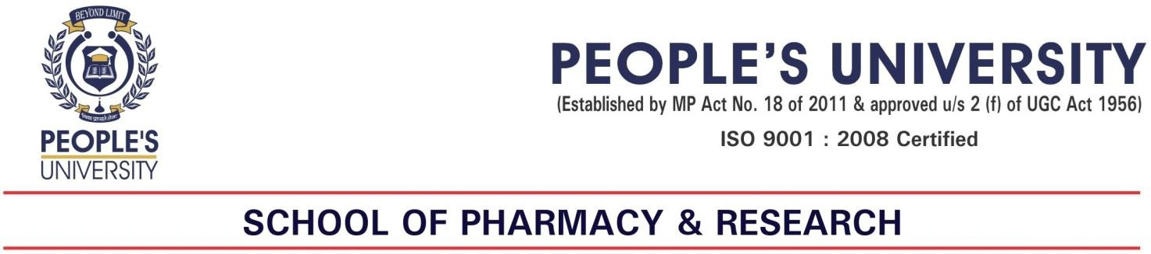

SUMMARY FOR EVENT
- Nature/ Type of Activity/Event: Industrial Visit
- Topic of Activity/Event: Industrial Visit
- Theme of Activity/Event: Training programme
- Level of Activity: Local / State / National / International –Local
- Venue/ Location: Hind Pharma
- Date :18/12/2021
- Academic Year :2021
- Organizer: SCHOOL OF PHARMACY AND RESEARCH. PEOPLE`S UNIVERSITY, BHOPAL
- Activity Coordinator/s: Mrs Rajni Dubey, Mr. Surendra Dangi, Mr. Hiresh Dutt
- Number of Participants (Students) from School of Pharmacy and Research
Number of Males-18 Number of Females-6 Total Number of Students-24
- Number of Participants from School of Pharmacy and Research (Teachers)
Number of Males-01 Number of Females- 01 Total Number of Teachers-02
Brief about the event (Minimum 50 words)
Industrial visit was carried out at HIND PHARMA on 20th December, 2021 especially for 7semester/IV-
year students. The first department that we visited was quality control area, Instrumental area, raw material and packaging material warehousing area where we got to learn how the raw and packaging materials are stored and labelled and we have seen different types of labels with different colours fixed on containers indicating its batch number, lot number, issue date, expiration date, retest date, and storage conditions. In another section processes of the manufacturing of the tablets were explained. They cover each and every small aspect of the tablet making by giving day todays life examples. Many students have asked the queries and the instructor has solved them very cleverly and politely the main objective behind the visit was to make student aware about how various department like Quality control area, instrumental area, Raw material store, liquid packaging area etc. We took almost an hour to see complete set of production which was followed by questions of students. In last we had an interaction of their CEO Dr. Radha Sharan Goswami, He ask few questions to the students and interacted very well. Dr. Bhaskar kumar Gupta Principal, SOPR has encourage the students to participate in the Industrial Visit. Event was successfully coordinated by Mrs Rajni Dubey, Associate Processor, Mr. Surendra Dangi, Associate Processor and Mr. Hiresh Dutt, Associate Processor.

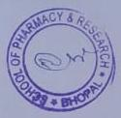

Outcome/Impact of event/activity in brief:
It is rightly said that “See & know’ is better than ‘read & learn’. Students have got real feel of company’s working after this visit. They got a chance to transfer their theoretical knowledge to practical implication. This will even help students to understand subject matter clearly in future also. Industrial visit was to provide an exposure to students about practical working environment.it lets students to know things practically through interaction, working methods and employment practices.

Ms Deepa Choudhary, Pharmacovigilance Associate,ADR monitoring centre,AIIMS Bhopal delivered on the topic ‘An Introduction to Pharmacovigilance Programme in India . she discussed about introduction of Pharmacovigilance,adverse drug reaction,limitation of preclinical and clinical trials. she also discussed about the how to fill ADR forms. she tried to sensitize students about career in pharmacovigilance. All the students of B.Pharm and M. Pharm actively took participation in the lecture. In this occasion various competitions like E- Poster, Essay and Quiz competition was held in online mode in School of pharmacy research on various theme related to pharmacovigilance. Students were enthusiastic for these events and took active participation in the competition. Competition was judged by Dr. Bhasker kumar Gupta, Professor, Mrs Eisha Ganju, Associate Professor, Dr. Jitendra bajaj Associate Professor and Surendra Dangi Associate Professor, In E-Poster competition , First and second prize was grabbed by Ria Talreja (SOPR,PU Bhopal B. Pharm II yr/3sem) , Vaishali Singh (SOPR,PU Bhopal B. Pharm III yr/5sem) respectively. In Essay competition First prize was grabbed by Vaishali Singh (SOPR,PU Bhopal B. Pharm III yr/5sem). In Quiz competition First prize was grabbed by Devendra singh Lodhi Singh (Gyan ganga college of Pharmacy,Jabalpur). Event was successfully organized by Mrs. Rajni Dubey, Associate professor SOP&R and Ms. Kajal Khan, Assistant professor SOP&R the winners were felicitated by Prize and Hard copy of certificates.

Attachment :( Where ever available)
- Photograph / Video Recording.
- Press Release.
- Fund utilization in case of external sponsorship.
- Letter of Collaboration/ sponsorship.

Sign Event coordinator: Sd/-  Name/s of Event coordinator: Mrs Rajni Dubey,  Mr. Surendra Dangi  Mr. Hiresh Dutt | Principal  SOPR

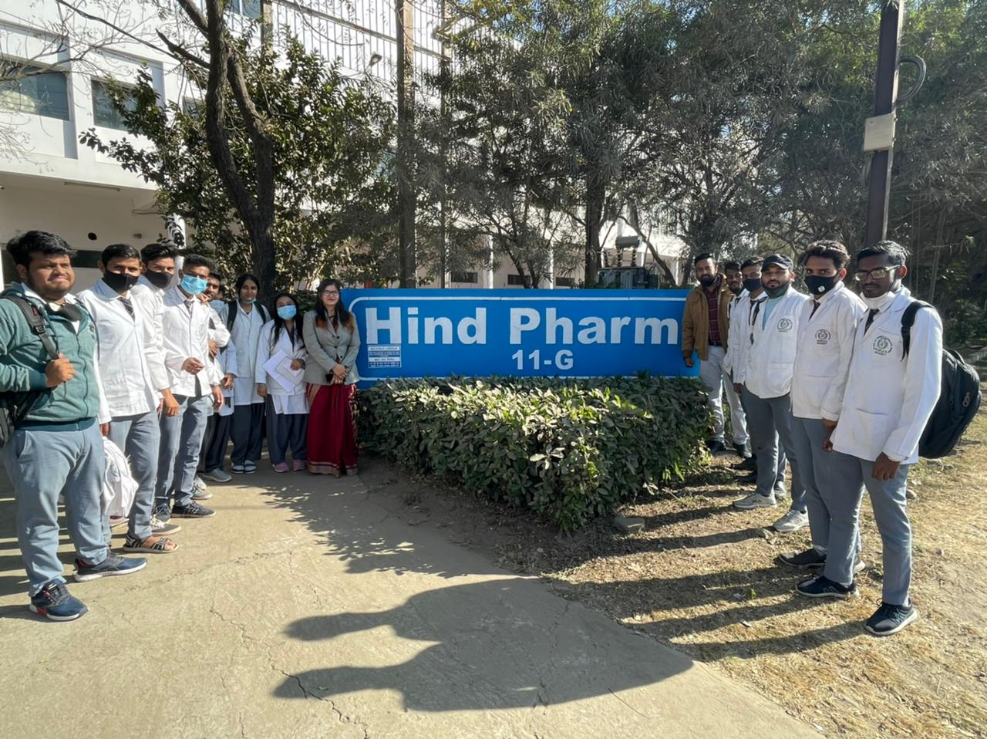
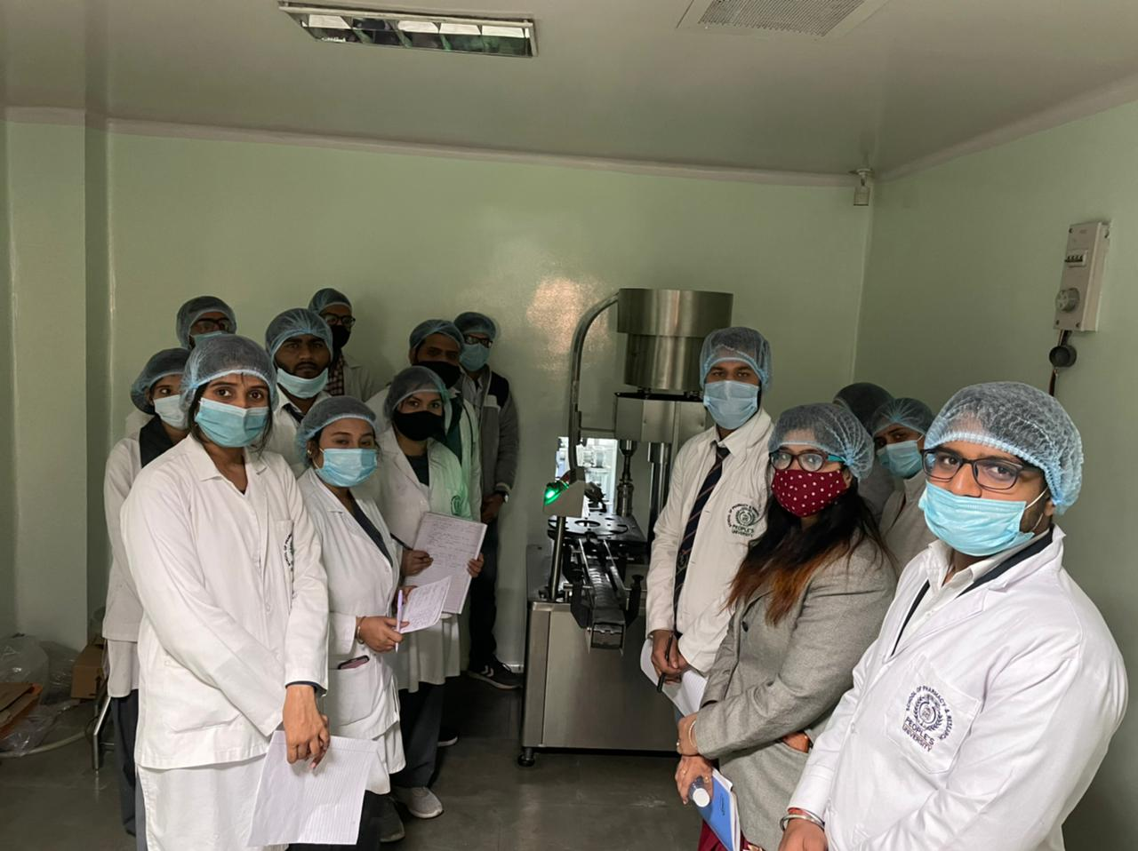
Faculty members with Students at the entrance of Hind Pharma
Demonstration of Bottle capping and sealing machine
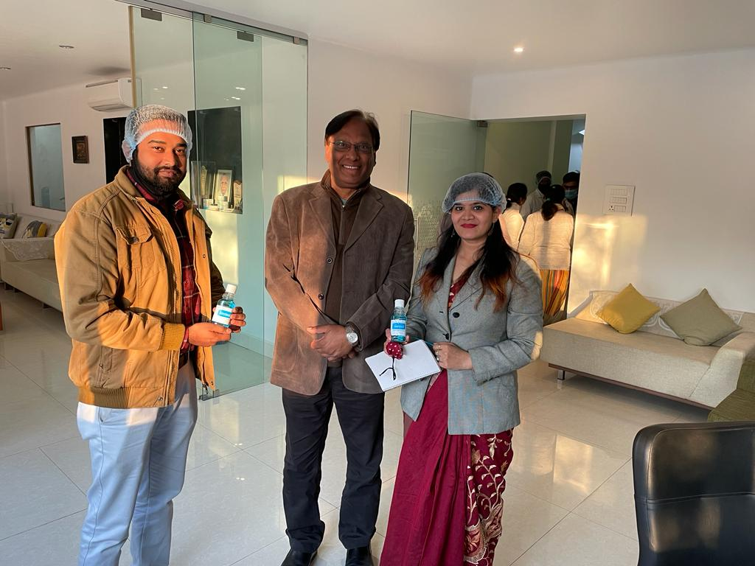

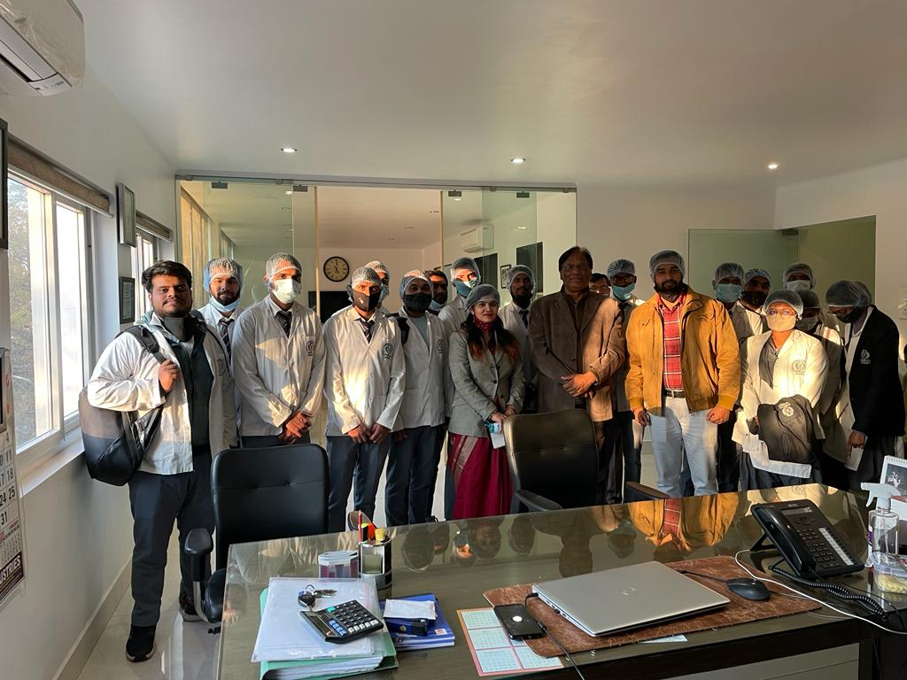
Motivational Address by CEO Dr. Radha Sharan Goswami with students

