ANNUAL FUNCTION (SNA WEEK)

Peoples college of Nursing and Research center organized Annual Function(SNA Week) from 02/03/2020 to 07/03/2020 in this function students participated in many activites likeDance,Song,Fancy Dress,Cooking,Skit, Flower Decoration,Hair Style,Mehndi, Indoor/Outdoor Games etc.
INAUGURATION

PRIZE DISTRIBUTION
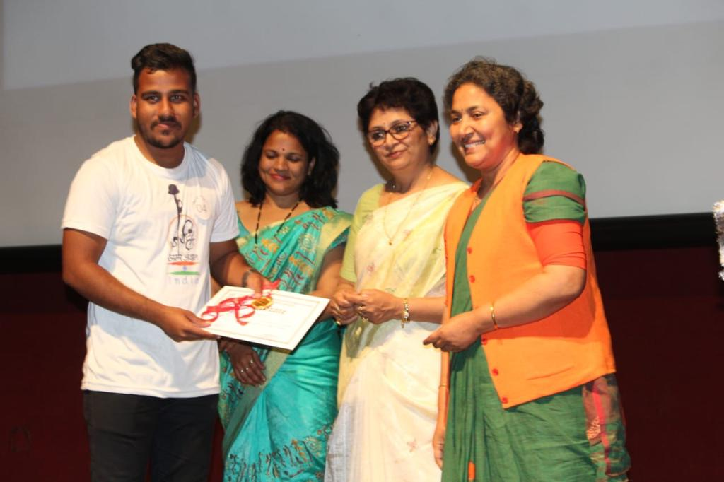
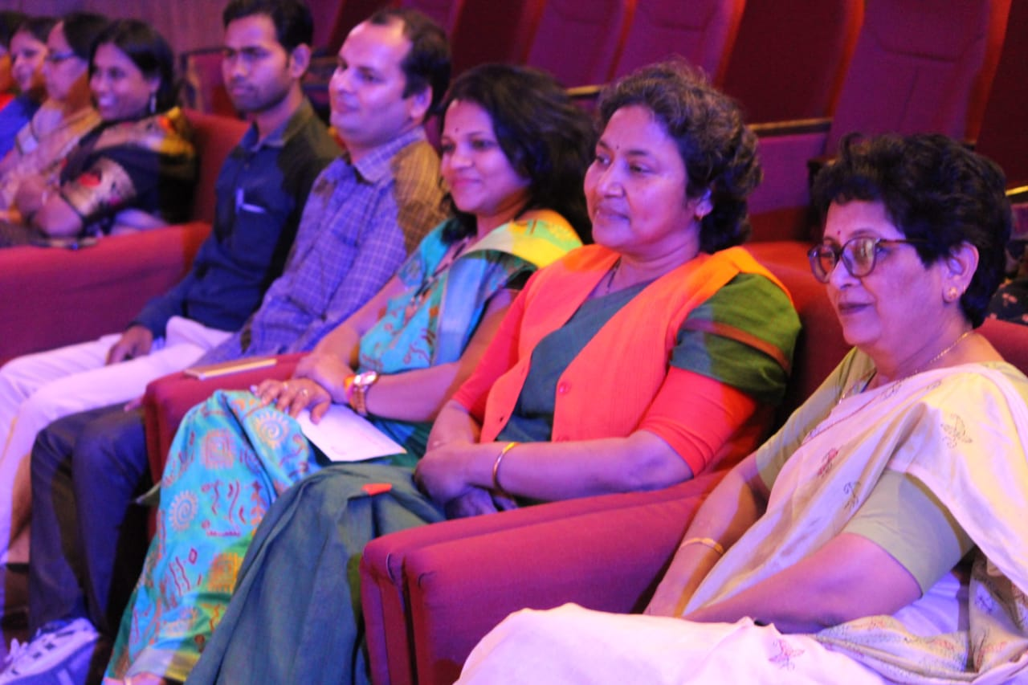

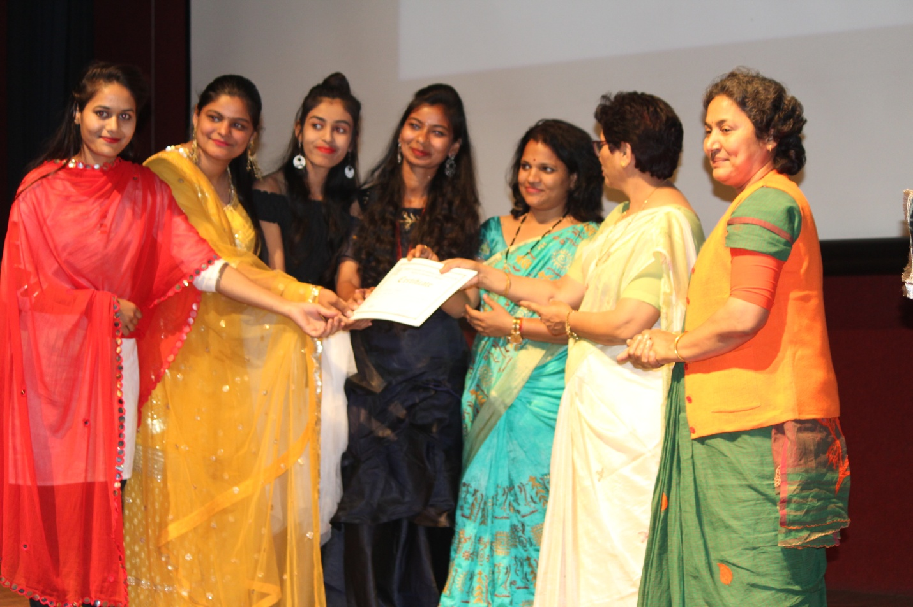

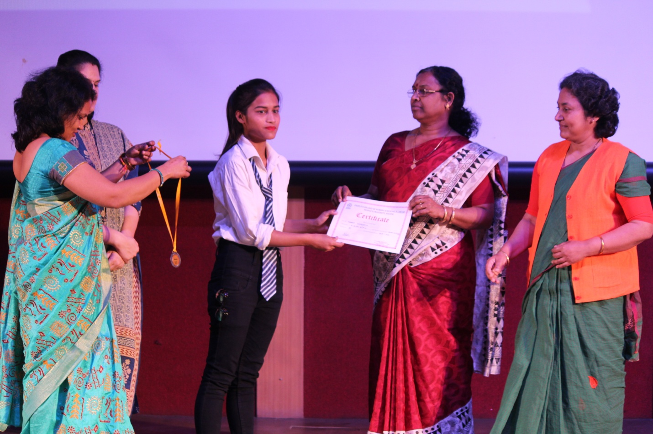

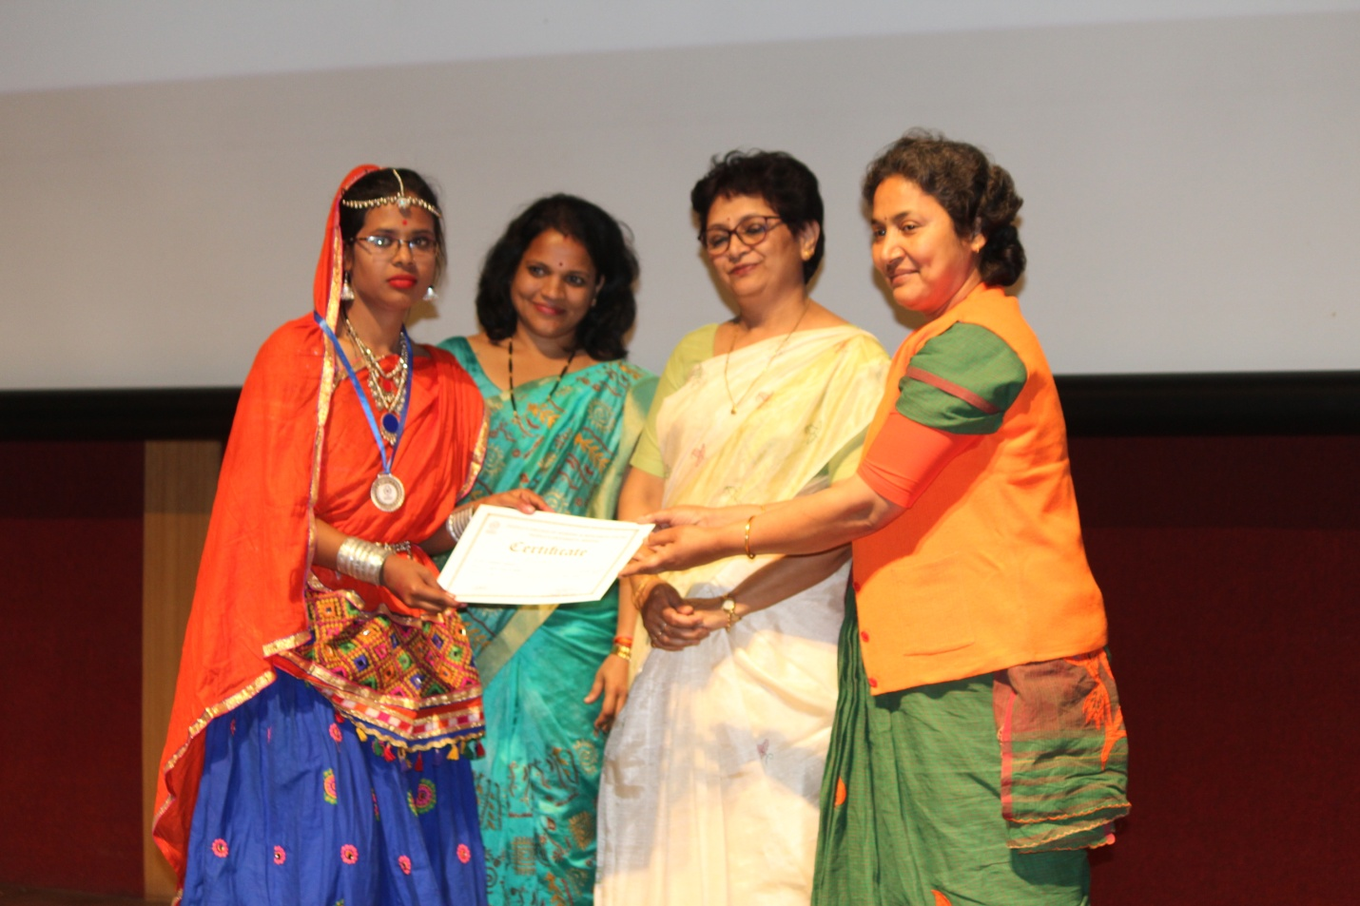
MEHANDI COMPITETION
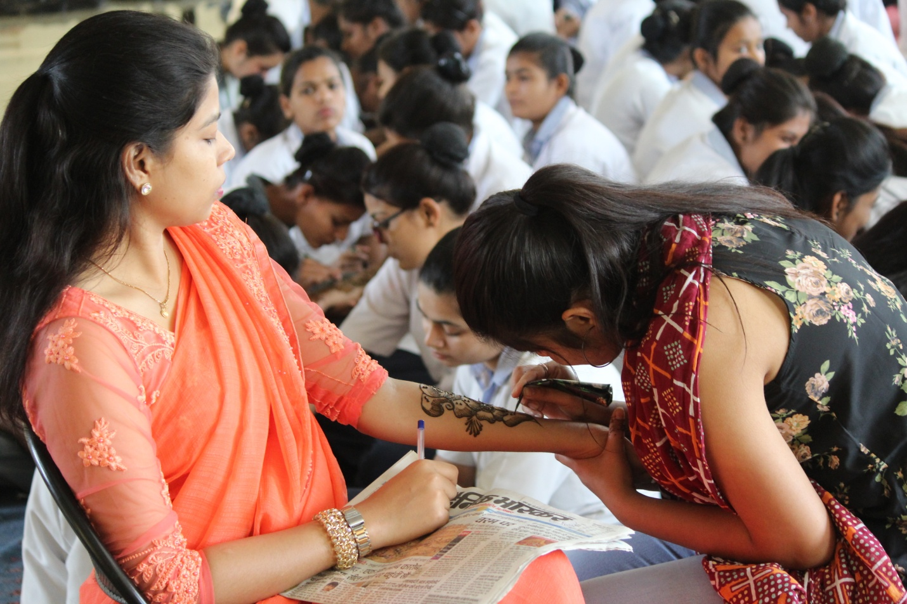

SALAD DECORATION
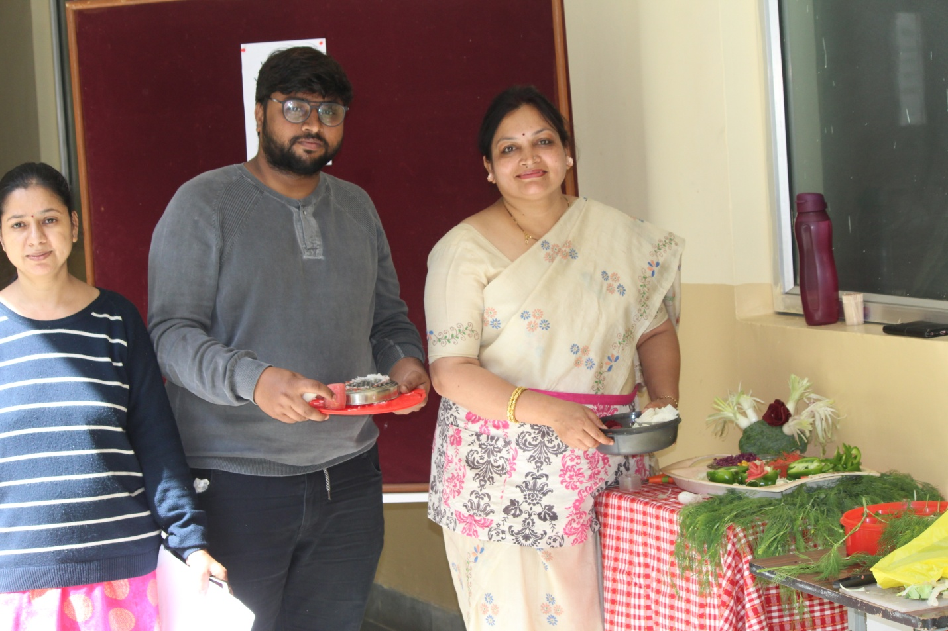
DANCE COMPITETION
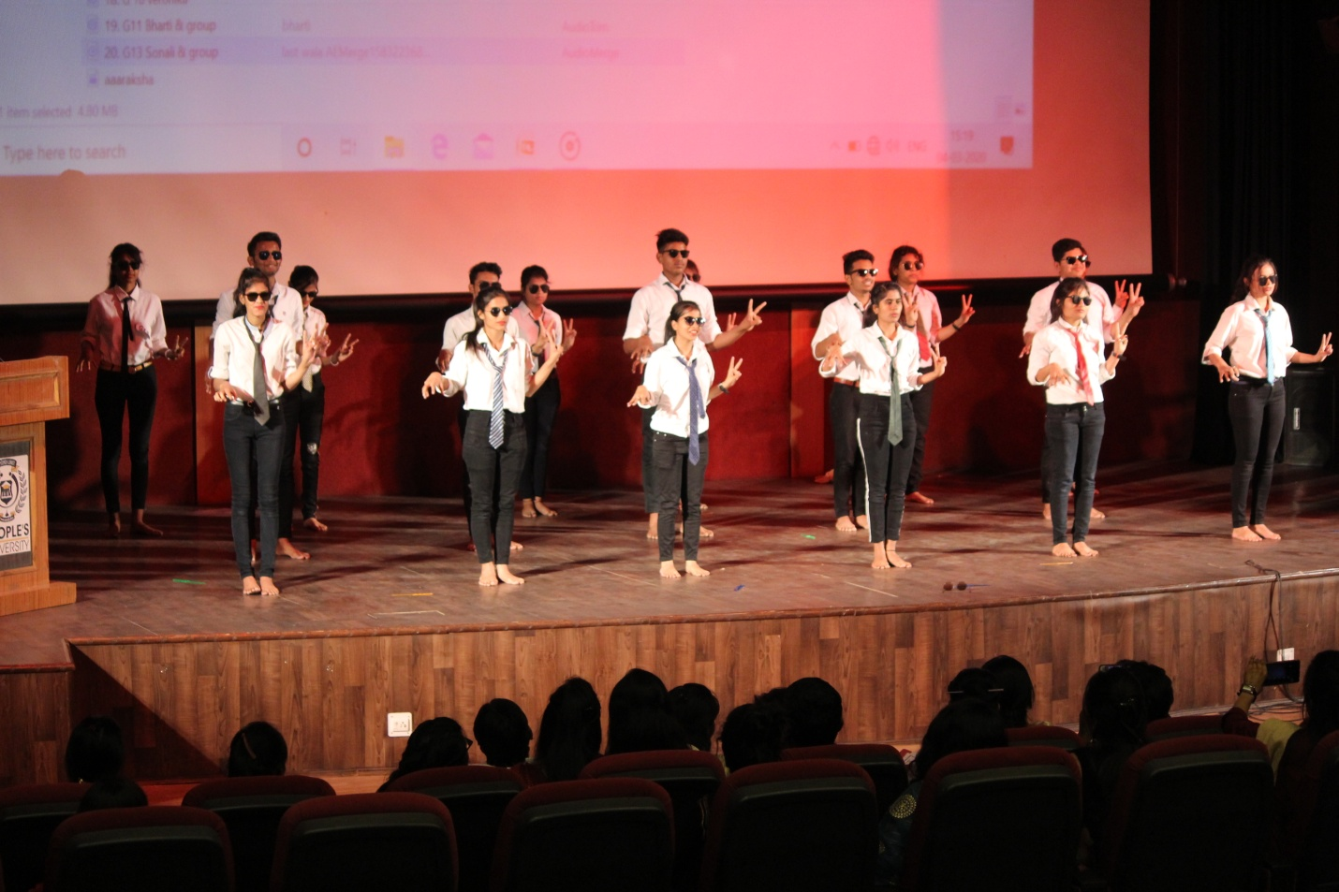

CRICKET(WINNERS)
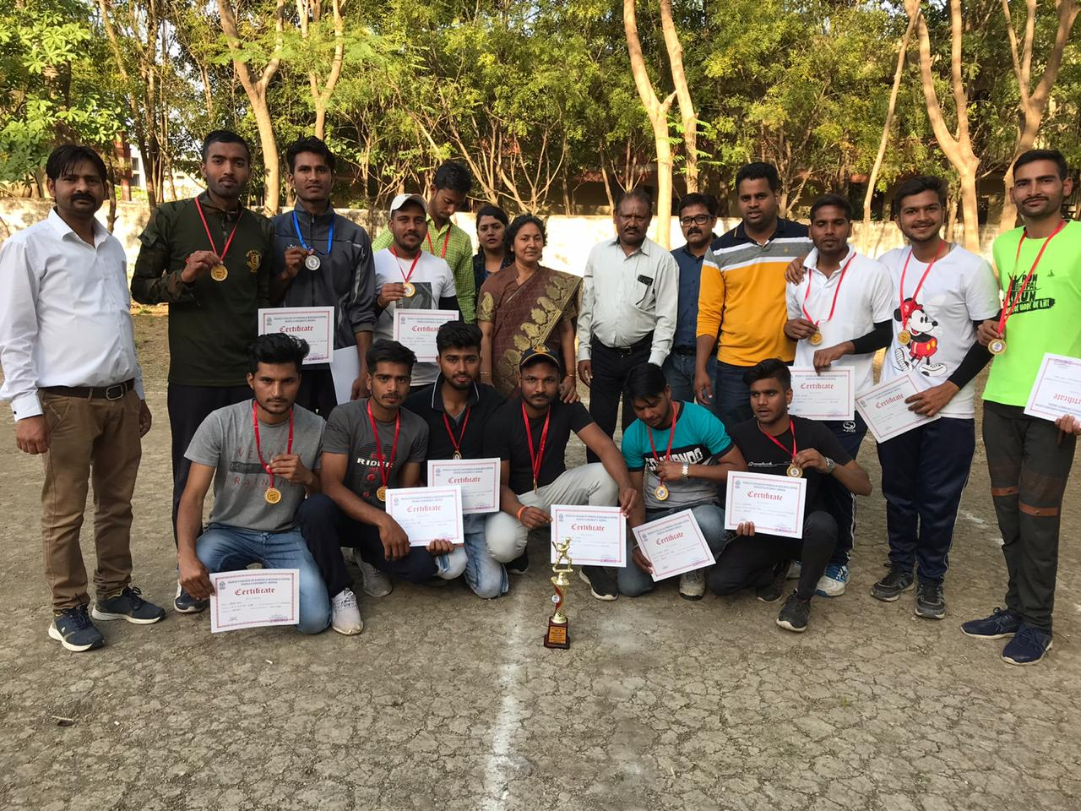
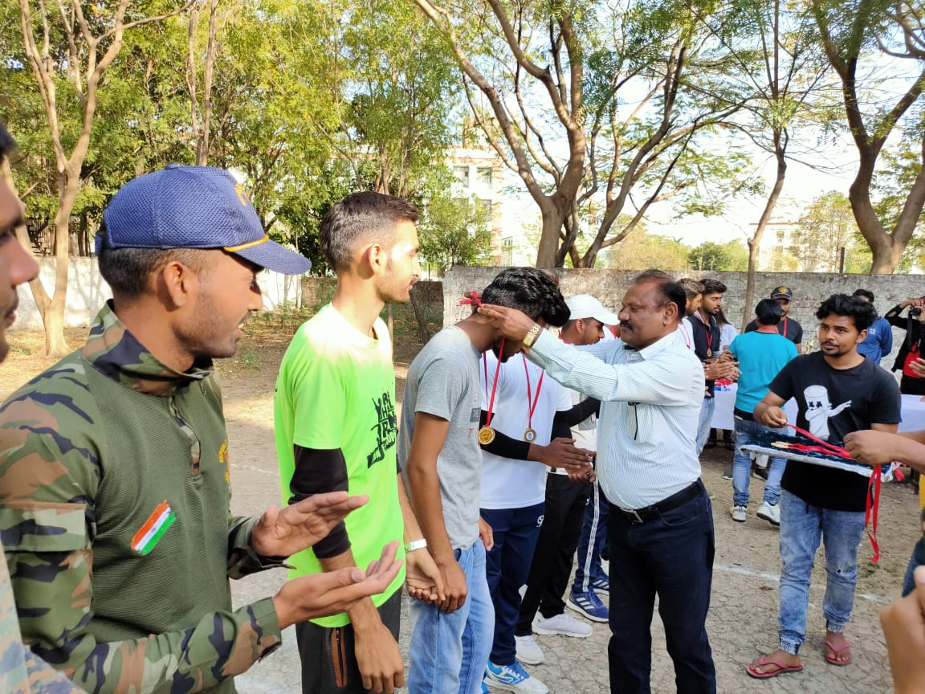
SKIT PLAY
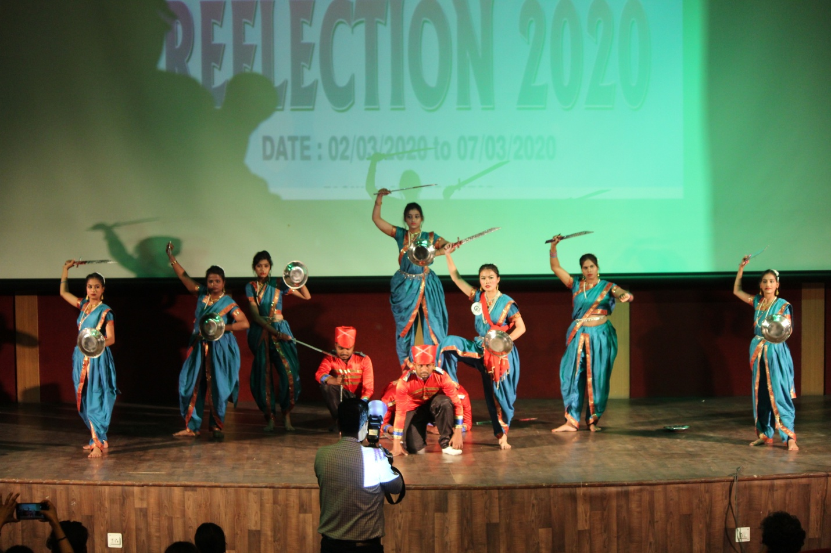
KABADDI (WINNERS)
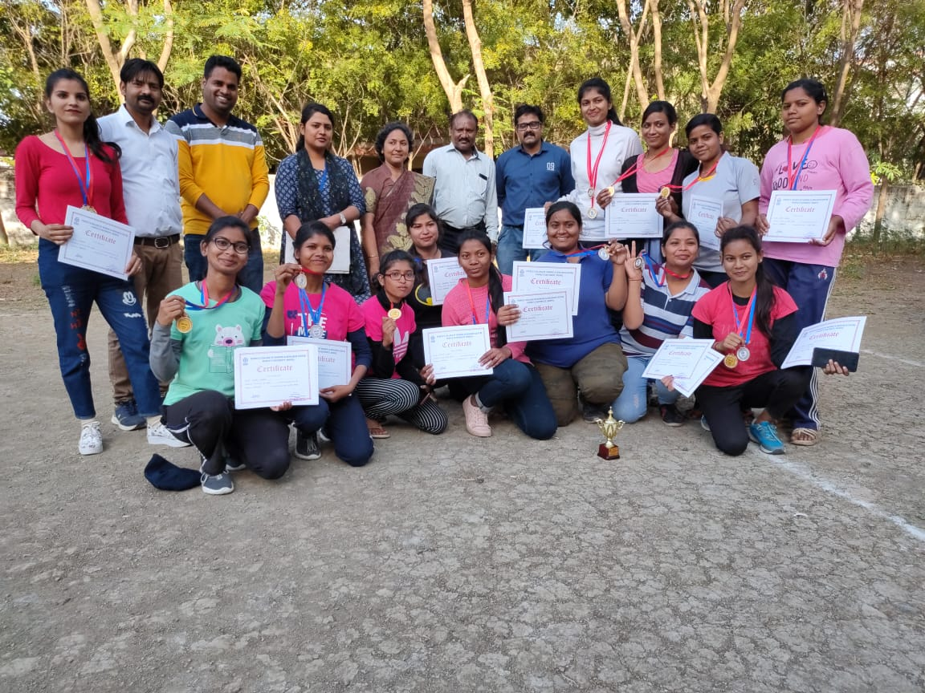
FACE PAINTING

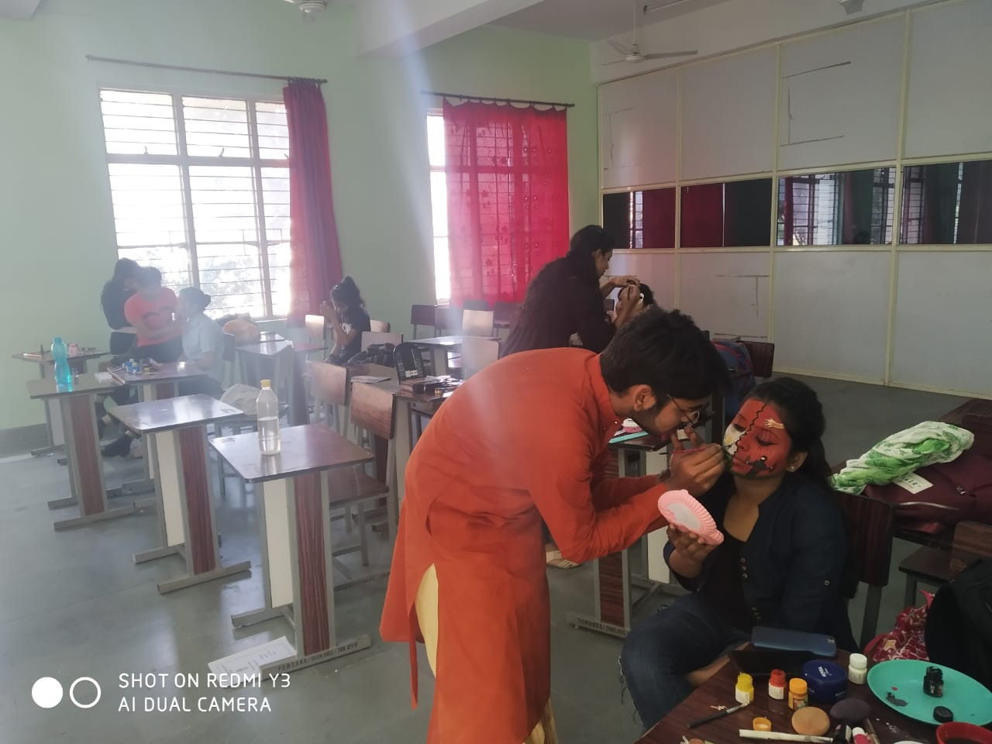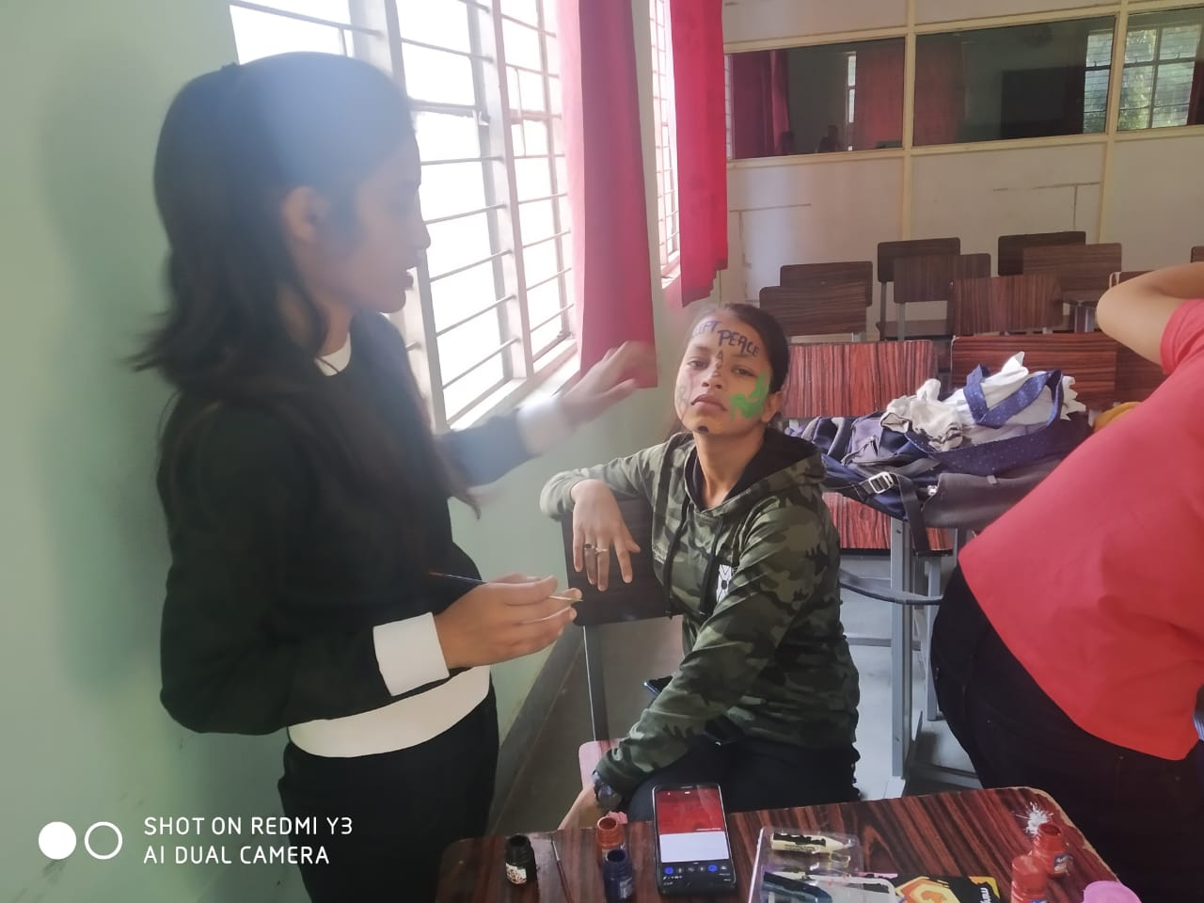

RANGOLI COMPITETION
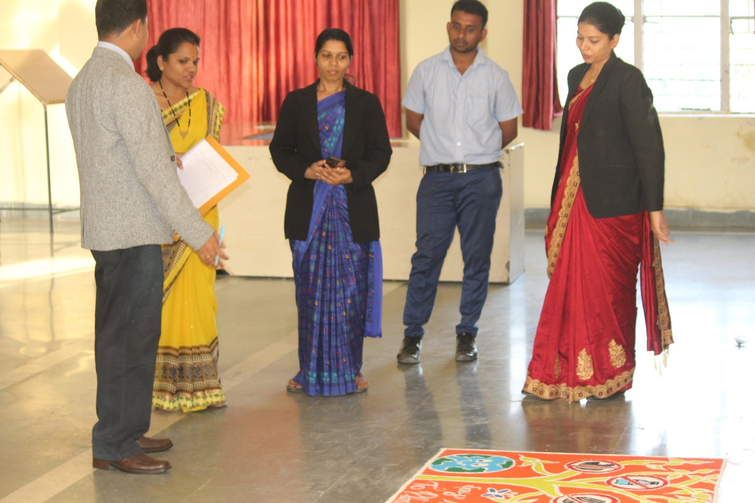
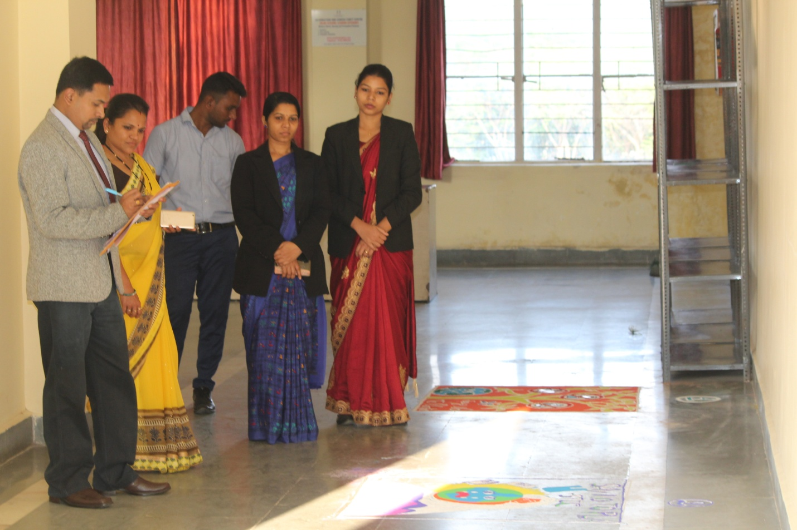

PERSONALITY COMPITETION
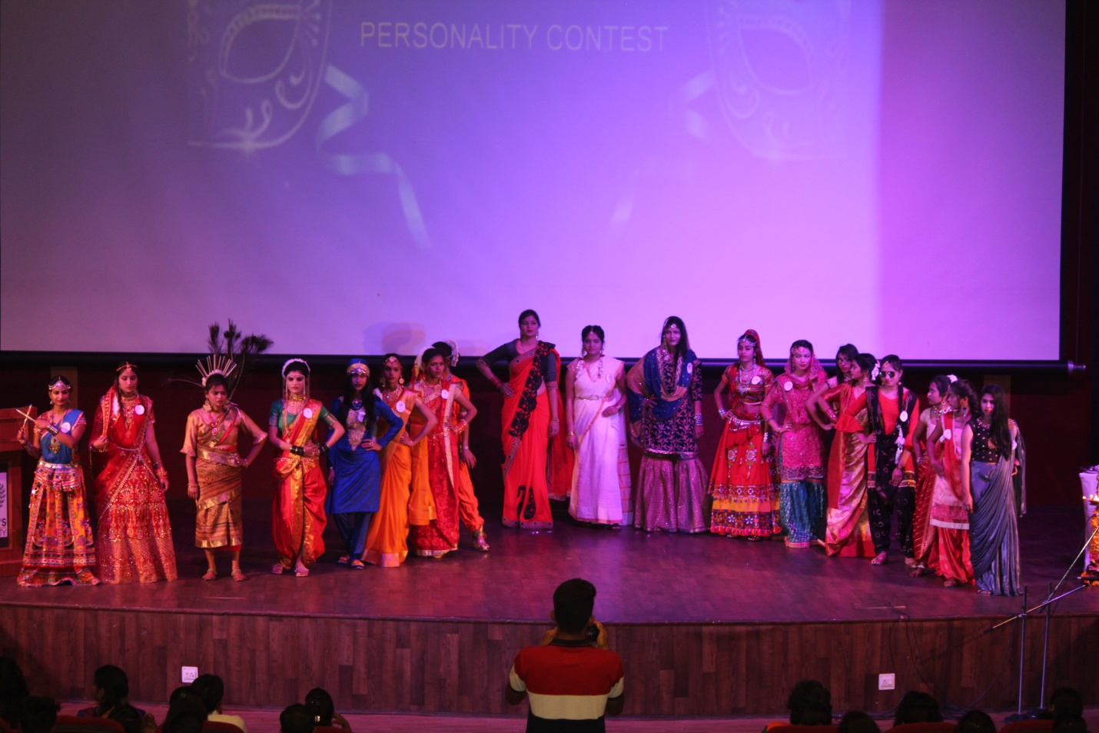

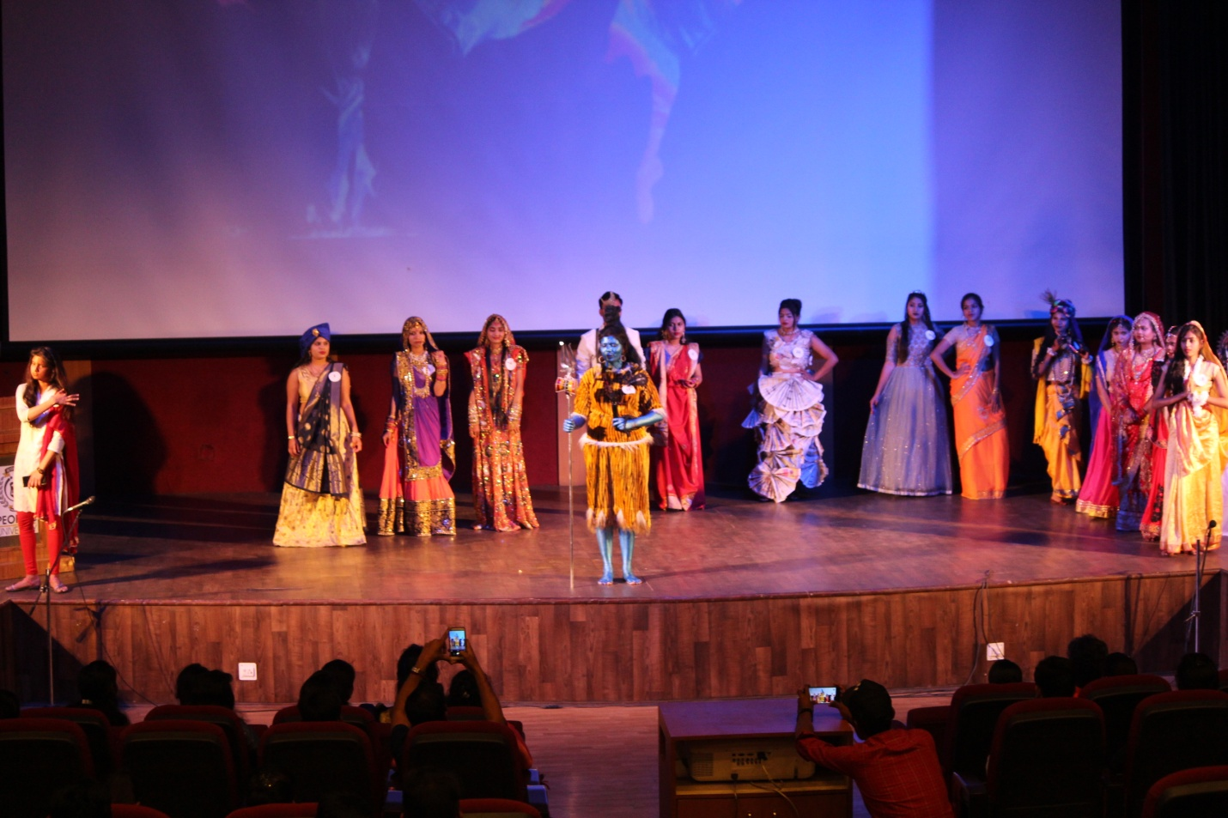

FOOD STALLS
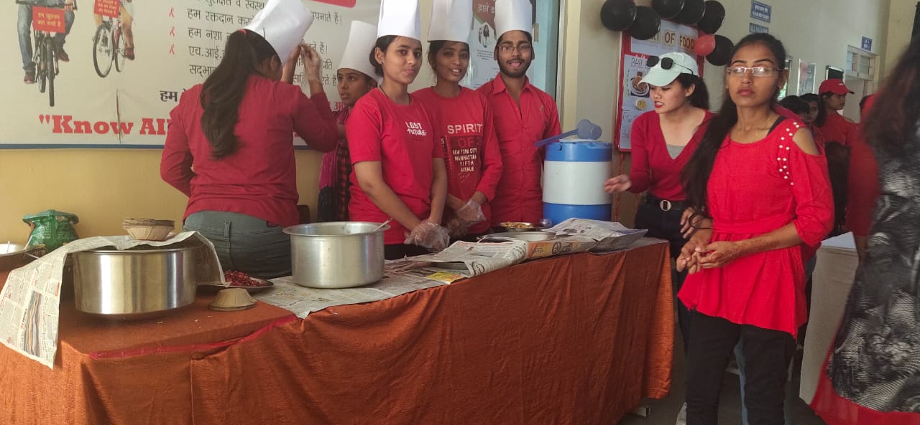
SKIT ON FIRST AID
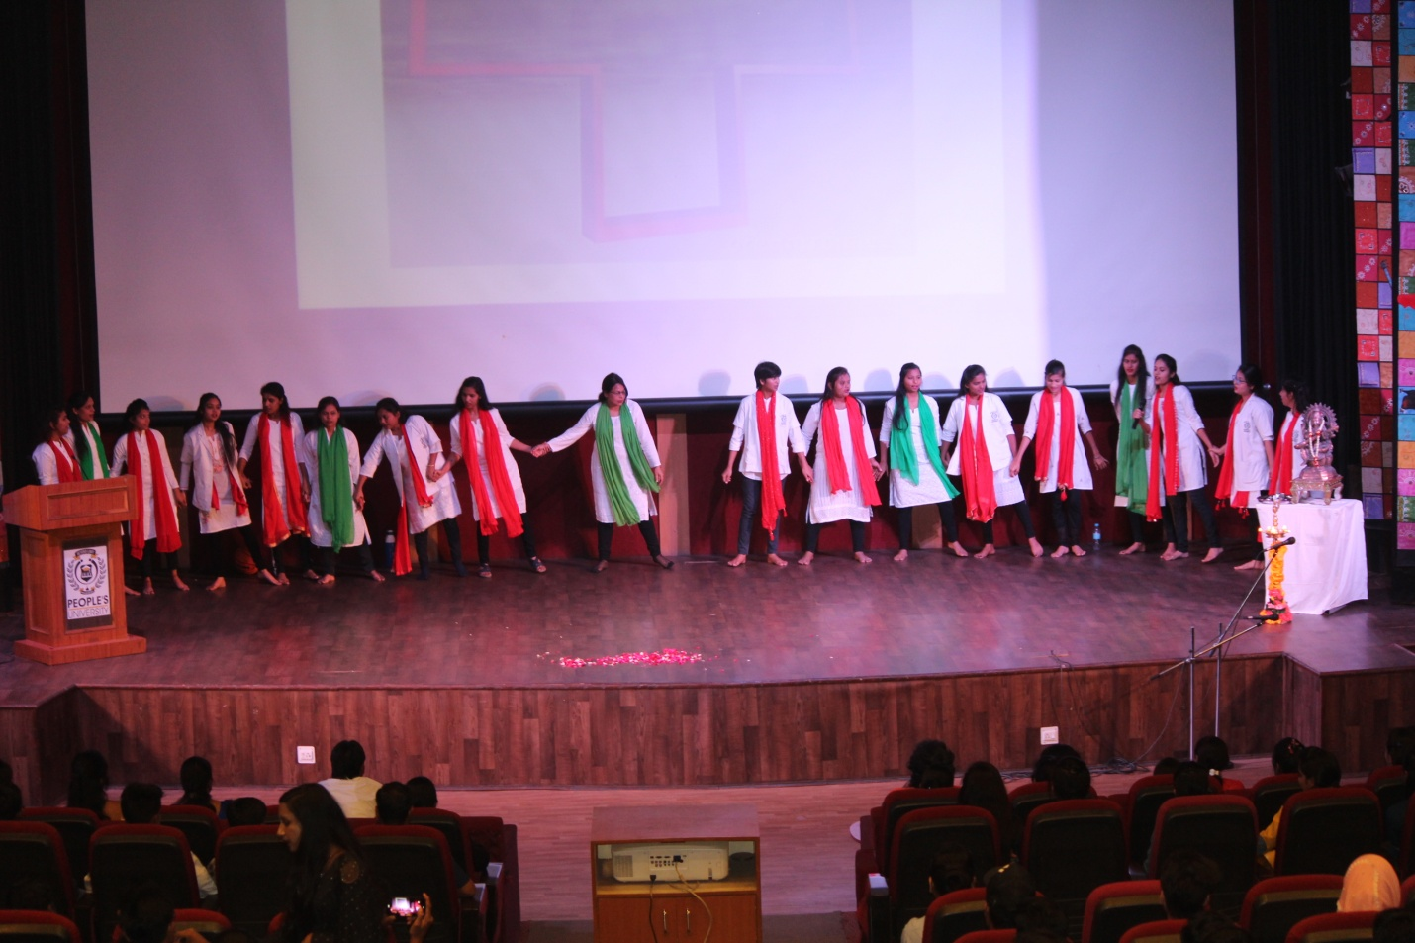

SARASWATI VANDANA

