**CONVOCATION CEREMONY**

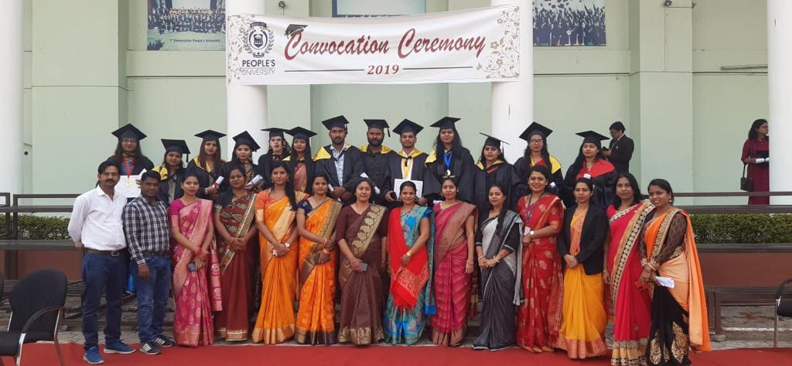The People’s University organized Convocation and Graduation Ceremony on 26th November 2019 Vice Chancellor Dr. Rajesh Kapoor, All Directors of People’s Group and All HOI of Instruction are present on this occasions.

