**BREASTFEEDING WEEK CELEBRATION REPORT**

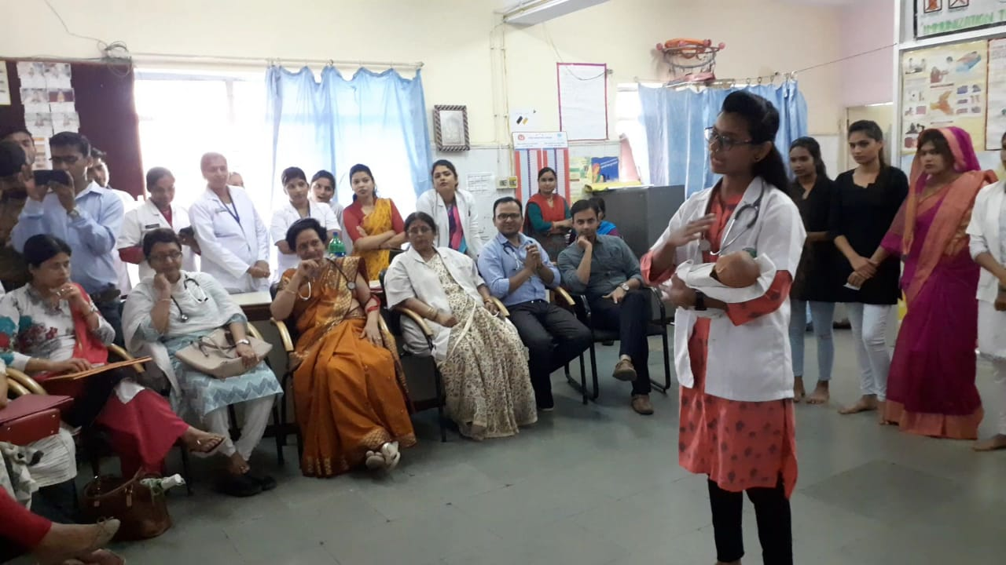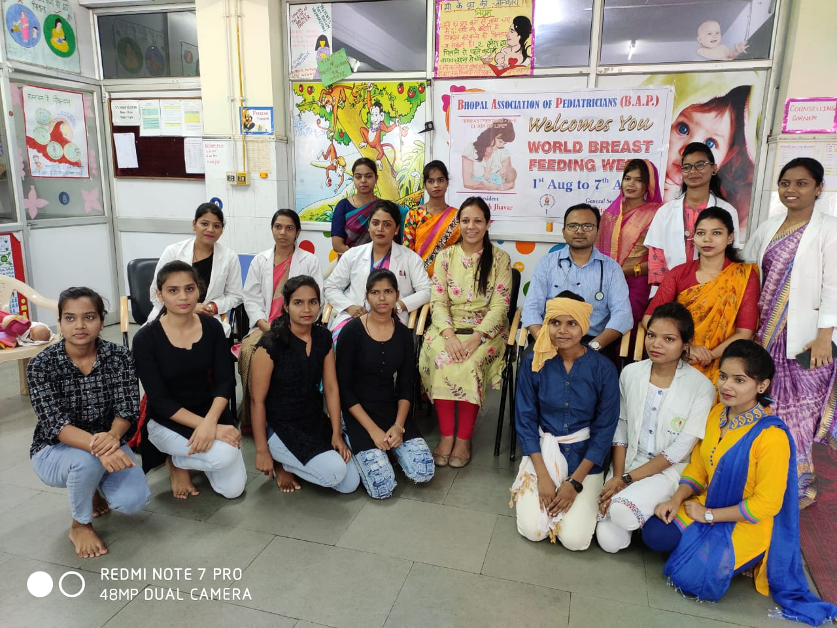World Breastfeeding week is celebrated every year from 1 to 7 August, to encourage breastfeeding and improve the health of babies around the world. The theme of World Breastfeeding 2019 is **“Encourage Parents, enable breastfeeding”.** People’s College of Nursing & Research Centre conducted a Program with the guidance of Prof. (Mrs.) Sunita Choubey, Principal, Prof (Mrs.) Rekha Rani Gupta (Vice Principal), Ms. Purnima Biragi (Asso. Prof.) & other Faculties. The students of B.Sc. Nursing & GNM has participated in various programmes which include Rangoli competition on 5 Aug 2019 & Role play on 06 Aug 2019 in People’s Hospital (NRC Ward), to encourage mother on breastfeeding & create awareness among parents regarding importance & benefit of Breastfeeding in enhancement of growth & development of child. At the end of programmes the participants were awarded with certificate.

