**CELEBRATION OF WORLD HEALTH DAY 2019**

The People’s College of Nursing & Research Centre celebrated ‘World Health Day’ on 6th April 2019. On this day we organized Inter college Poster competition. The programme was conducted under the guidance of Prof.(Mrs.) Jyoti M. Nirapure (Incharge principal). The chief guest and Judge of the programme are **Mrs. Susen Saji** , **Principal (SAM College of Nursing) and Mrs. Girja Unni ,NS (People’s Hospital).**

Total Forty students participated in the competition on WHO’s theme “**Universal Coverage: Everyone, Everywhere”.**

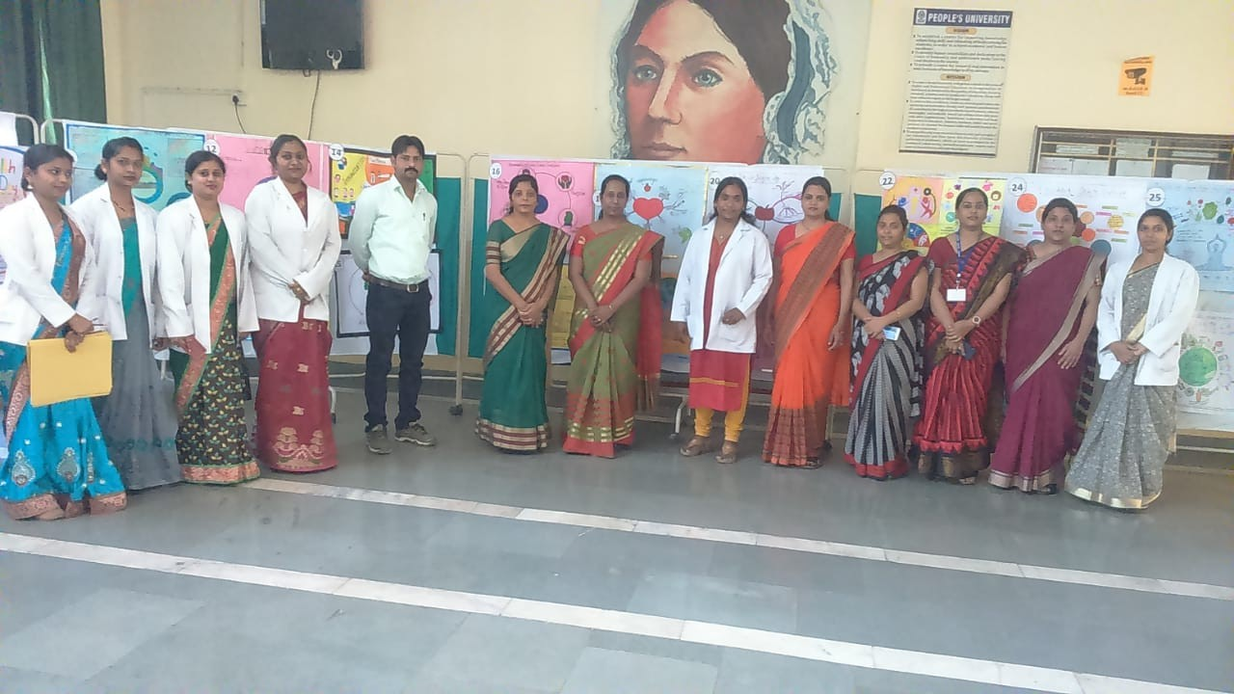

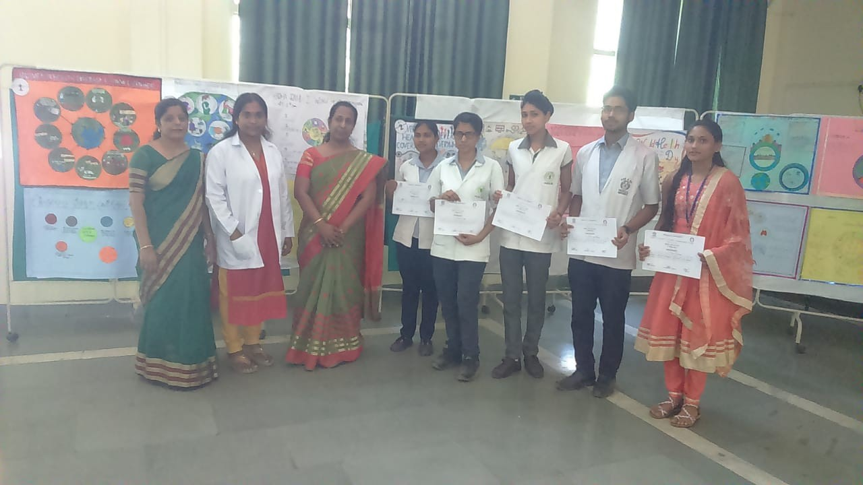

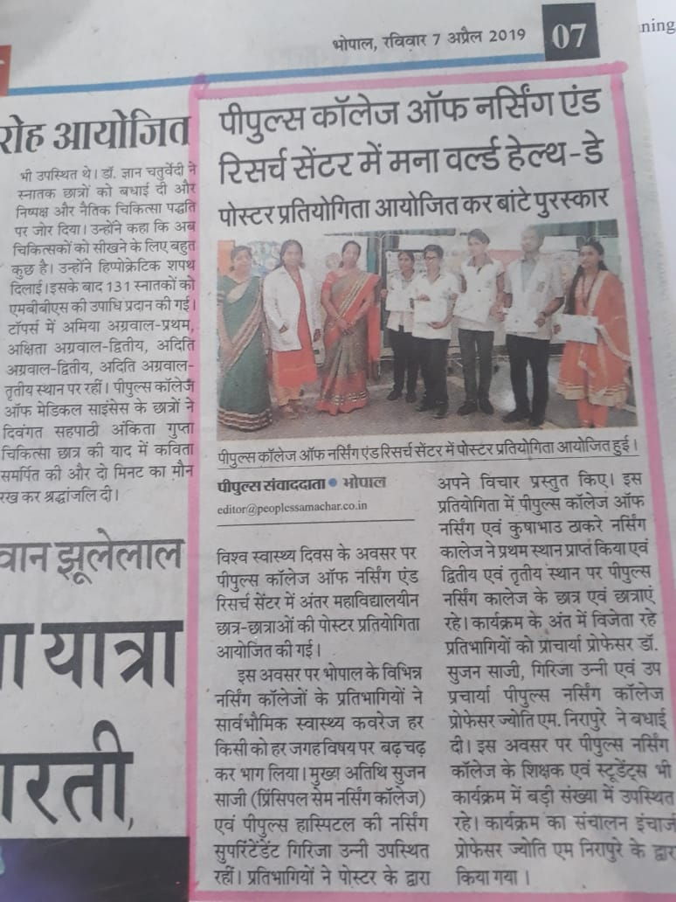

A